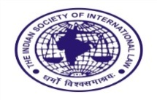
THE INDIAN SOCIETY OF INTERNATIONAL LAW
Cordially invites you
To the Monthly Discussion
on
“The Treaty on Biological Diversity beyond National Jurisdiction (BBNJ): Strengths and Limitations”
by
Captain Sarabjeet S Parmar
Senior Fellow, National Maritime Foundation, New Delhi

on
Friday, 12 May 2023 at 5 pm
Venue: Room No. 204

All are welcome

Pravin H Parekh Narinder Singh
President Secretary General

